Terraform Challenge-02
- Create VPC
- Create Internet gateway
- Create Custom Route Table
- Create Subnet
- Associate subnet with Route Table
- Create Security Group to allow port 22.80,443
- Create a network interface with an ip in the subnet that was created in step 4
- Assign an elastic IP to the network interface created in step 7
- Create Ubuntu server and install/enable apache2

Step 1:Provider
A provider tells Terraform which cloud/platform to communicate with.
Here:
Terraform
|
↓
AWS Provider
|
↓
AWS
And:
region = "eu-north-1"
means:
Create the AWS resources in the eu-north-1 region.
This is the AWS Stockholm region.
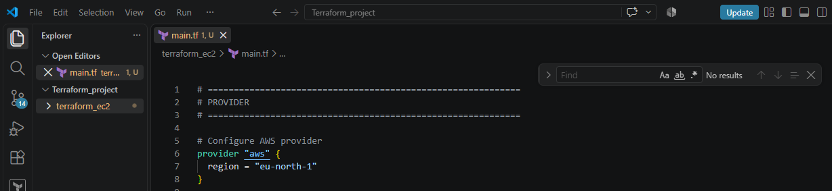

Step 2: Create VPC
Code:
resource "aws_vpc" "main" {
cidr_block = "10.0.0.0/16"

tags = {
Name = "my-vpc"
}
}
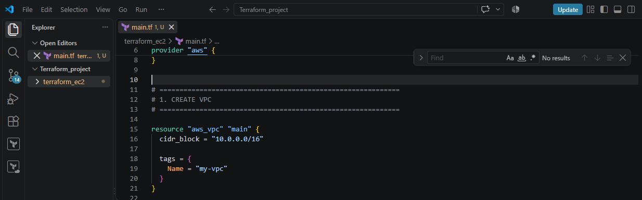
We are creating our own private network inside AWS.
We are creating:
VPC
10.0.0.0/16
The /16 gives you a large private IP range.
10.0.0.0
↓
10.0.0.1
10.0.0.2
10.0.0.3
...

Terraform syntax
resource "aws_vpc" "main"
means:
resource type = aws_vpc
resource name = main
Therefore, Terraform refers to this VPC as:
aws_vpc.main

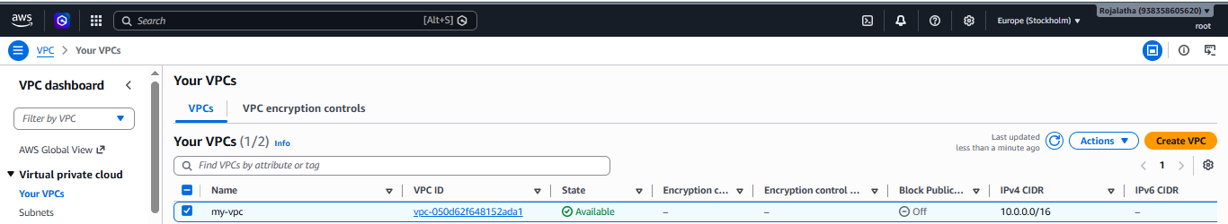

Step 3: Internet Gateway
Code:
resource "aws_internet_gateway" "igw" {
vpc_id = aws_vpc.main.id

tags = {
Name = "my-internet-gateway"
}
}

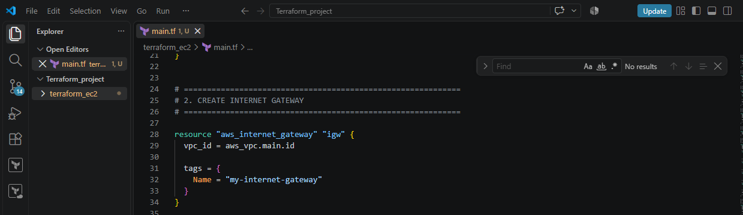
An Internet Gateway (IGW) allows communication between your VPC and the internet.
Think of it as a door from your VPC to the internet.
VPC
|
|
Internet Gateway
|
|
Internet
Notice this:
vpc_id = aws_vpc.main.id
This means:
Attach the Internet Gateway to the VPC that Terraform created above.
Terraform automatically knows the VPC ID after creating it.
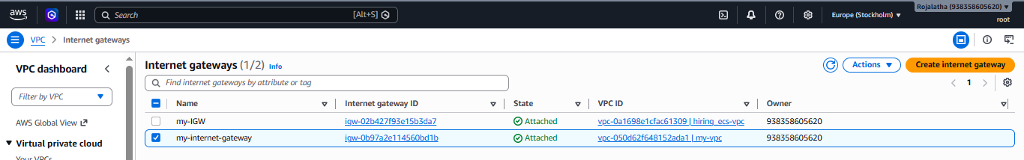

Step 4: Route Table
Code:
resource "aws_route_table" "public" {
vpc_id = aws_vpc.main.id

route {
cidr_block = "0.0.0.0/0"
gateway_id = aws_internet_gateway.igw.id
}

tags = {
Name = "my-public-route-table"
}
}

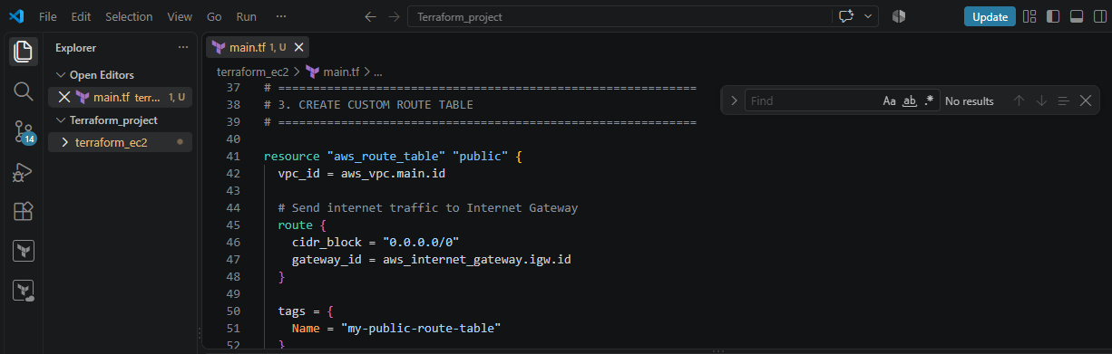
This is very important.
A route table tells AWS where network traffic should go.
You have:
cidr_block = "0.0.0.0/0"
This means:
Any destination that isn't otherwise specifically matched.
In simple words:
Internet traffic
↓
0.0.0.0/0
↓
Internet Gateway
And:
gateway_id = aws_internet_gateway.igw.id
means:
Send that traffic through the Internet Gateway.
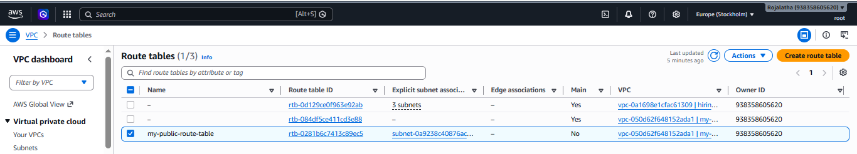

Step 5: Create Subnet
Code:
resource "aws_subnet" "public" {
vpc_id = aws_vpc.main.id
cidr_block = "10.0.1.0/24"
availability_zone = "eu-north-1a"

tags = {
Name = "my-public-subnet"
}
}

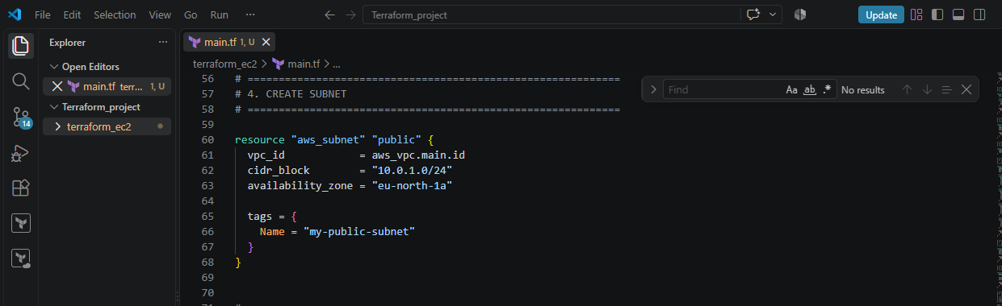
A subnet is a smaller network inside your VPC.
Your VPC is:
10.0.0.0/16
Inside that VPC, you're creating:
10.0.1.0/24
Think:
VPC
10.0.0.0/16
|
+------ Subnet
10.0.1.0/24
You're also specifying:
availability_zone = "eu-north-1a"
So this subnet is created in:
eu-north-1a

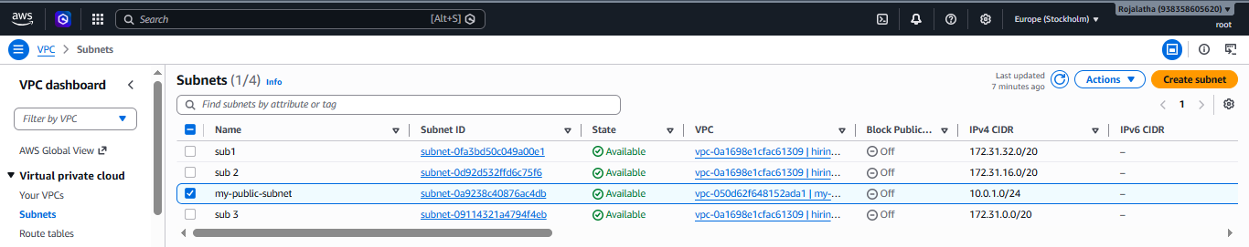

Step 6: Associate Subnet with Route Table
As created the subnet and route table separately.
Now we have to connect them:
resource "aws_route_table_association" "public" {
subnet_id = aws_subnet.public.id
route_table_id = aws_route_table.public.id
}

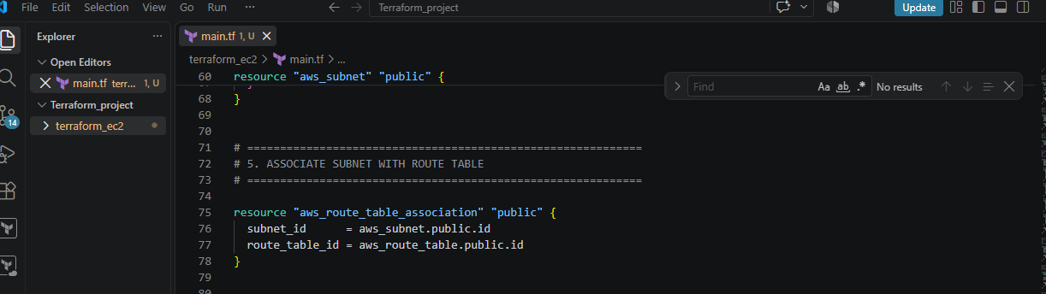
Think:
Subnet
|
↓
Route Table
|
↓
Internet Gateway
|
↓
Internet
Without this association, the subnet would not use this particular route table.
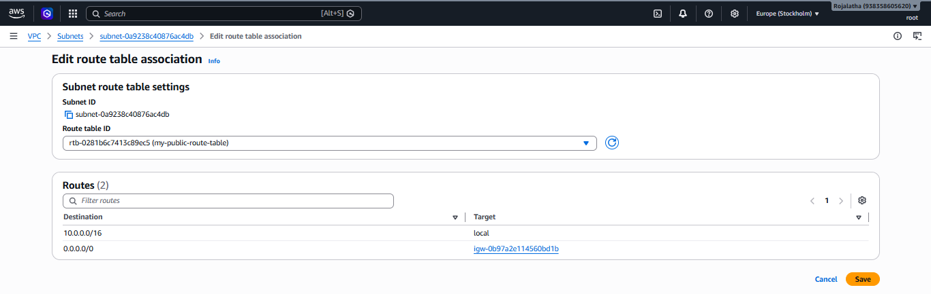

Step 7: Security Group
Code creates:
resource "aws_security_group" "web_sg"

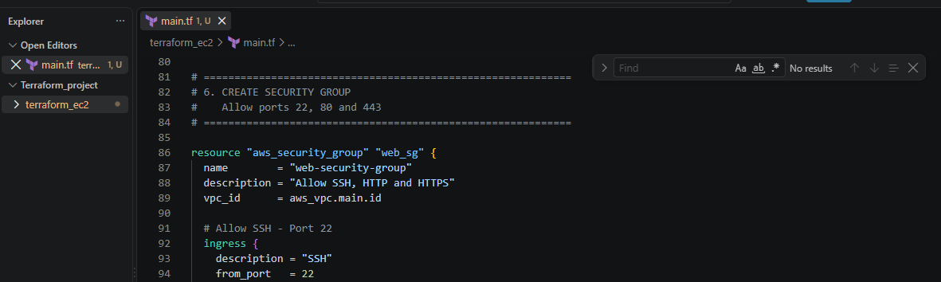
A Security Group acts like a virtual firewall for your EC2/network interface.
You allow:
Port 22 → SSH
Port 80 → HTTP
Port 443 → HTTPS
For example:
ingress {
description = "HTTP"
from_port = 80
to_port = 80
protocol = "tcp"
cidr_blocks = ["0.0.0.0/0"]
}
This means:
Allow TCP traffic on port 80 from anywhere.
So:
Internet
|
| Port 80
↓
Security Group
|
↓
EC2
Three inbound rules
Port | Purpose
22 | SSH
80 | HTTP / Apache
443 | HTTPS
You also have:
egress {
from_port = 0
to_port = 0
protocol = "-1"
cidr_blocks = ["0.0.0.0/0"]
}
This allows the server to make outbound connections to anywhere.
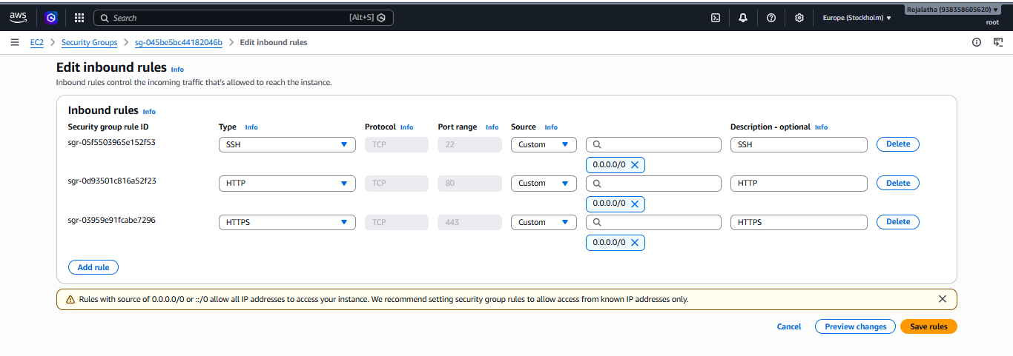

Step 8: Network Interface
Create an ENI:
resource "aws_network_interface" "web_eni" {
subnet_id = aws_subnet.public.id
private_ips = ["10.0.1.10"]
security_groups = [aws_security_group.web_sg.id]
}

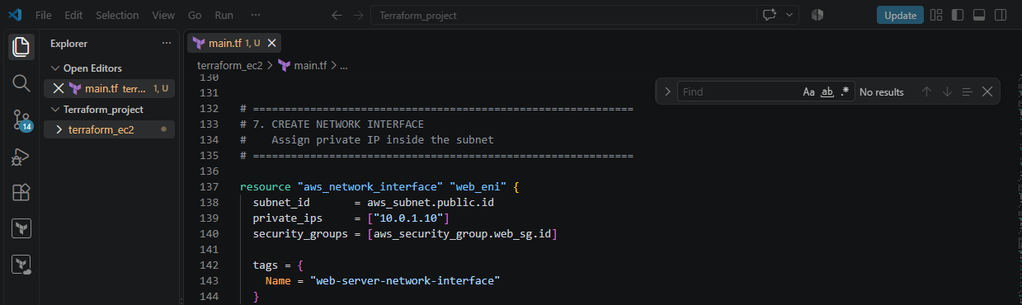
ENI = Elastic Network Interface
Think of it as the network card of the EC2 server.
It gets:
Private IP:
10.0.1.10
And it is placed inside: 10.0.1.0/24 subnet
It also uses your security group.
So:
EC2
|
↓
Network Interface
|
├── Private IP: 10.0.1.10
|
└── Security Group
├── 22
├── 80
└── 443
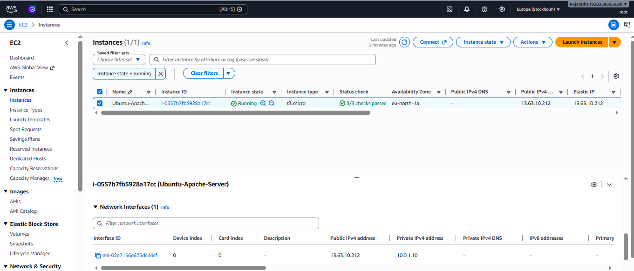

Step 9: Elastic IP
Create:
resource "aws_eip" "web_eip" {
domain = "vpc"

network_interface = aws_network_interface.web_eni.id
associate_with_private_ip = "10.0.1.10"
}

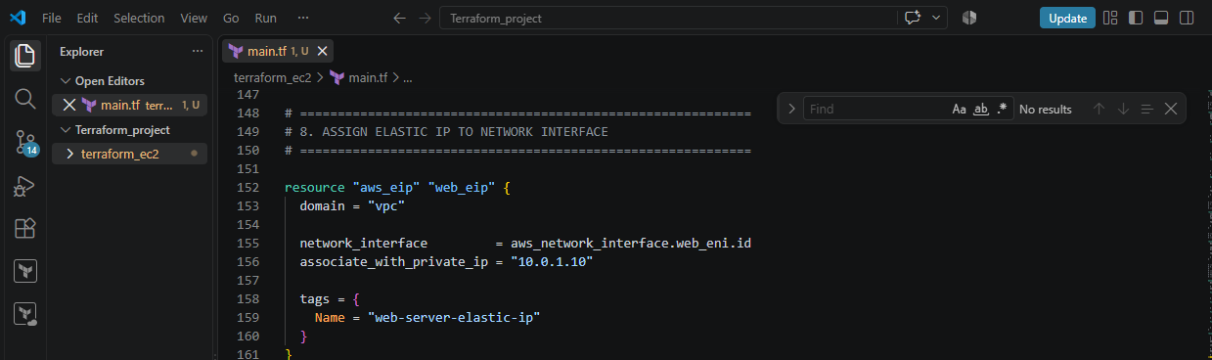
An Elastic IP is a public IPv4 address.
Our server has:
Private IP
10.0.1.10
The Elastic IP gives it a:
Public IP
So conceptually:
Internet
|
↓
Elastic IP
|
↓
10.0.1.10
|
↓
Network Interface
|
↓
EC2
This allows you to access Apache from the internet.
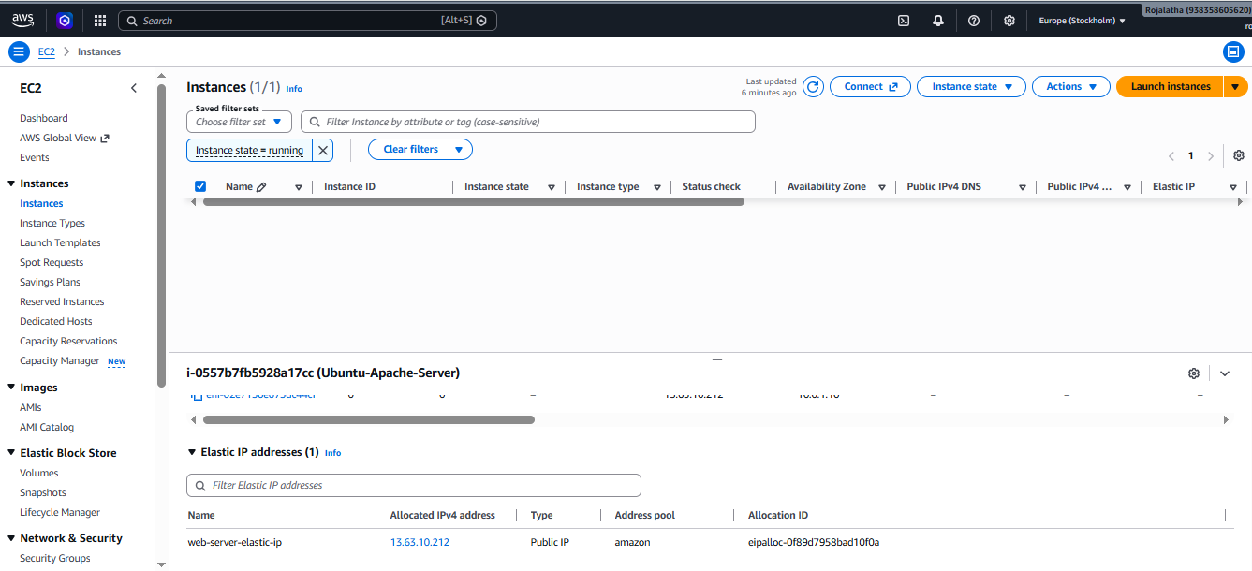

Step 10: Find the Ubuntu AMI
This part:
data "aws_ami" "ubuntu" {
is different from a resource.
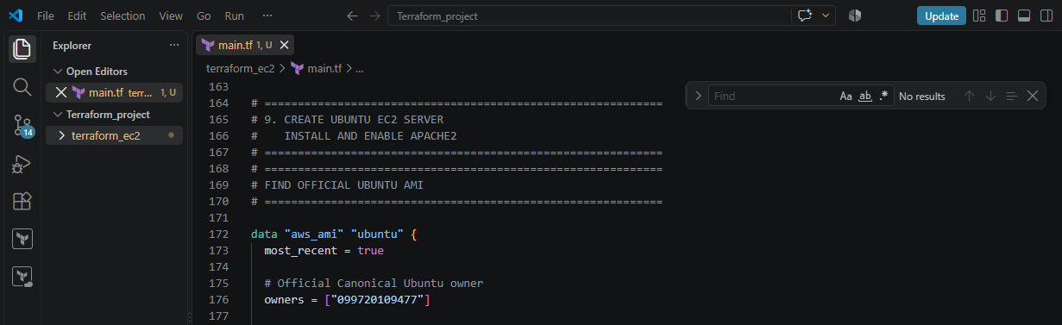
We are not creating an AMI.
We're asking AWS to find a suitable Ubuntu AMI.
Then Execute Terraform init and Terraform apply:
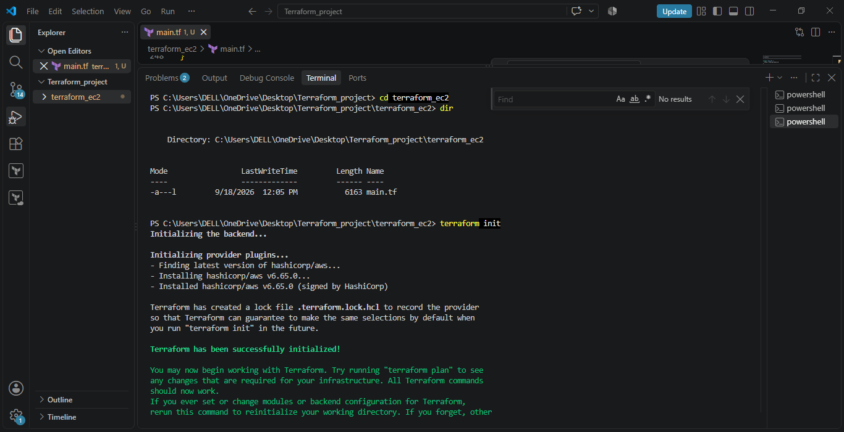
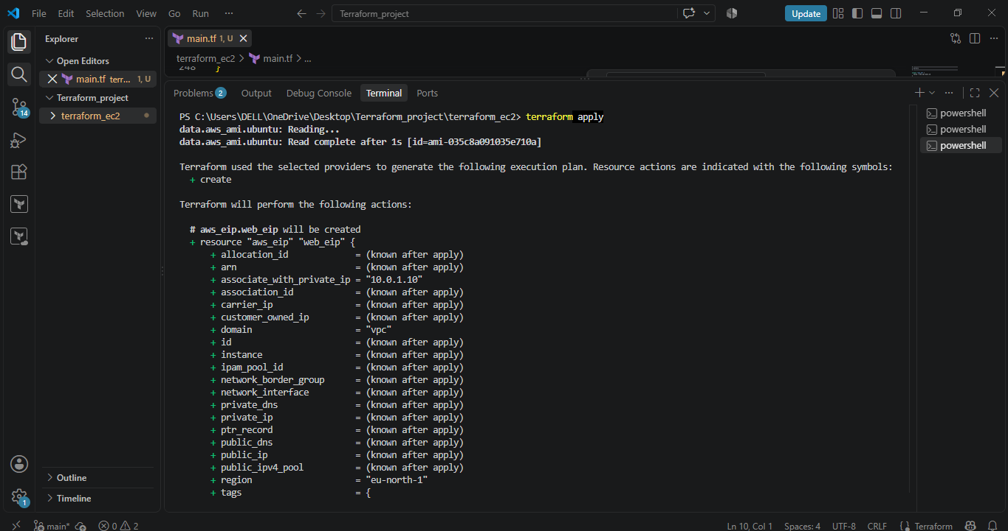

Step 11: Create EC2
Now the actual EC2 server:
resource "aws_instance" "web_server" {
You specify:
ami = data.aws_ami.ubuntu.id
This means:
Use the Ubuntu AMI that we found above.
Then:
instance_type = "t3.micro"
means:
Create a t3.micro EC2 instance.
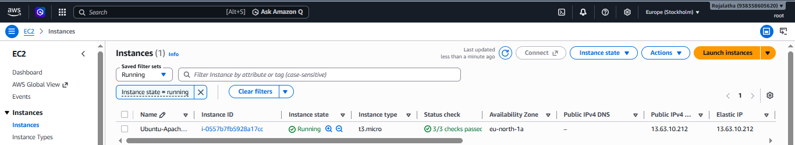

Step 12: Key Pair
We have:
key_name = "Euo.S"
This tells AWS which existing EC2 key pair should be associated with the instance.
Important distinction:
key_name
↓
AWS EC2 Key Pair NAME
It is not the .pem filename.
So if AWS Console shows the key pair name as:
Euo.S
then:
key_name = "Euo.S"
is correct.
If the actual key pair name is different, change it to the exact AWS key-pair name.

Step 13: Attach the Network Interface to EC2
Code:
network_interface {
network_interface_id = aws_network_interface.web_eni.id
device_index = 0
}
This tells Terraform:
Use the ENI I created earlier as the primary network interface of this EC2 instance.
So now:
EC2
|
↓
ENI
|
├── 10.0.1.10
├── Security Group
└── Elastic IP

Step 14: User Data
This is one of the most useful parts.
We have:
user_data = <<-EOF
#!/bin/bash

apt-get update -y

apt-get install -y apache2

systemctl enable apache2

systemctl start apache2

echo "Hello from Terraform Ubuntu Apache Server" > /var/www/html/index.html
EOF
This is a startup script.
When the EC2 instance starts, Ubuntu executes this script.

Step 1
apt-get update -y
Updates the Ubuntu package information.

Step 2
apt-get install -y apache2
Installs Apache.

Step 3
systemctl enable apache2
Makes Apache start automatically when the server boots.

Step 4
systemctl start apache2
Starts Apache immediately.

Step 5
echo "Hello from Terraform Ubuntu Apache Server" > /var/www/html/index.html
Creates the web page.
When you visit:
http://<Elastic-IP>
Apache should return:
Hello from Terraform Ubuntu Apache Server

Step 15: Outputs
At the end we have:
output "vpc_id" {
value = aws_vpc.main.id
}
Terraform will display the VPC ID after terraform apply.
Similarly:
output "subnet_id"
displays the subnet ID.
output "network_interface_id"
displays the ENI ID.
output "private_ip"
displays:
10.0.1.10
And:
output "elastic_ip"
displays the public IP.
Finally:
output "instance_id"
displays the EC2 instance ID.

